Research

Simulation 1

Turkey_trained_v8_platinum

Class Images Instances Box(P R mAP50 mAP50-95): 100%|██████████| 7/7 [01:33<00:00, 13.34s/it]

all 100 672 0.45 0.422 0.416 0.23

door 24 36 0.25 0.269 0.2 0.116

window 99 636 0.65 0.575 0.631 0.344

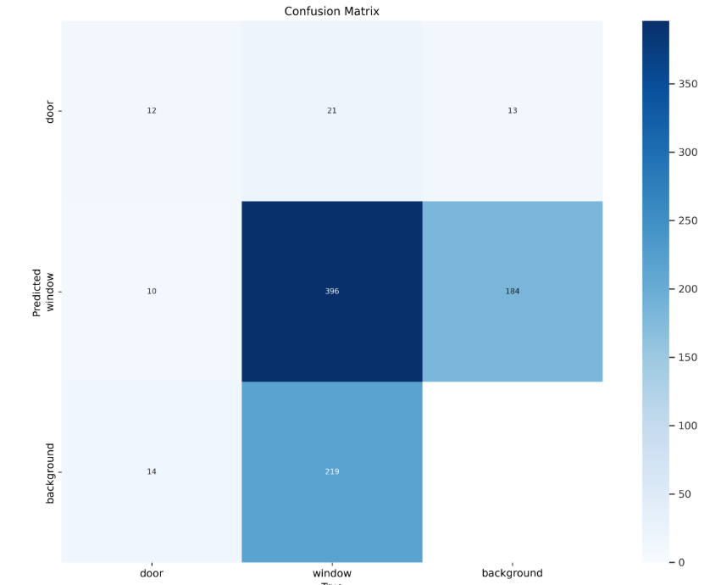

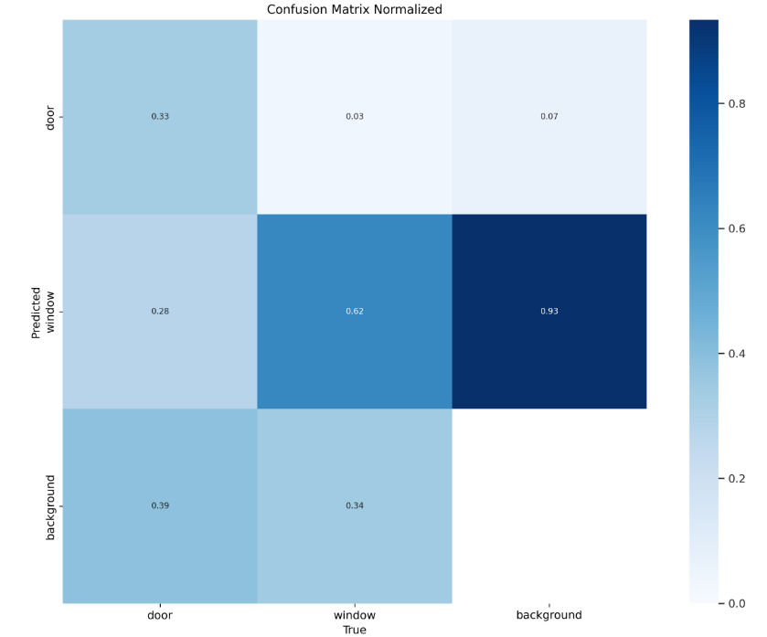

Simulation 2

Stage 1 on 10 freeze for 10 epochs

